**2021 – 2025**

**Disability Access   
and Inclusion Plan**

Partial - Logo

**WESTERN AUSTRALIAN**

**Electoral Commission**

Level 2, 111 St Georges Terrace PERTH WA 6000

Telephone: (08) 9214 0400 or 13 63 06

Facsimile: (08) 9226 0577

Email: [waec@waec.wa.gov.au](mailto:waec@waec.wa.gov.au)

Website: [www.elections.wa.gov.au](http://www.elections.wa.gov.au)

The DAIP is available in alternative formats on request, in electronic format, hard copy format in both standard and large print, in audio format on cassette or compact disc, and by email.

# Background

Established in 1987, the Western Australian Electoral Commission (the Commission) is committed to ensuring that Western Australia’s electoral system meets the highest standards of independence, impartiality and reliability. Our purpose is to provide Western Australians with an electoral experience that they understand, trust and can access easily and efficiently.

Our key areas of operation are:

* the conduct of State, local government elections, referendums and private elections.
* maintaining the State electoral roll.
* promoting community understanding and participation in electoral processes.

## Disability in Western Australia

In Western Australia, the prevalence of disability in the community is measured. According to *A Western Australia for Everyone: State Disability Strategy 2020-2030,[1] t*here are 411,500 people with disability in WA and 68,000 primary carers of people with disability. This is a significant proportion of the community.

Based on current figures, it is estimated that a significant number of the Western Australian community who have a disability, would be over 18 years of age and potentially eligible to be enrolled and able to vote.

## Our Disability Access and Inclusion Plan (DAIP)

The Commission has demonstrated ongoing commitment to people with disability through its *Disability Action and Inclusion Plan* (DAIP).

The focus for our fourth DAIP (December 2021- December 2025) will be on improving access to electoral services for people with disability. This forms part of a broader commitment under the Commission’s *Strategic Plan 2021-2025* to embrace diversity. The DAIP provides strategies to be undertaken during the year and during elections where many initiatives can be progressed. Within the timeframe of this DAIP, the Commission will conduct a State general election (March 2025) and local government elections (October 2023 and October 2025) in addition to its other core business responsibilities.

## Planning for Better Access

The Commission is committed to access and inclusion, equal opportunity, substantive equality and diversity.

The Commission is particularly focused on improving and modernising electoral processes. The Commission will continue to explore electronic and/or internet voting options for electors with disability in order to assist them to vote with independence.

Given the significant number of people currently affected by disability who are eligible to vote in Western Australia and future predictions, it is important to ensure that people are provided with:

* convenient access to the electoral system.
* the means to easily understand the processes involved.
* the opportunity to cast their votes with the same knowledge and access as electors without disability.

# Access and Inclusion Policy Statement

The Commission seeks to provide appropriate and quality services for all electors in an ever-changing electoral environment. As a small organisation serving all current and potential Western Australian electors, there are challenges in meeting the diverse needs within the community. However, we are committed to ensuring that the needs of electors with disability are considered and access requirements are a priority.

Commission staff, consultants and contractors will be encouraged to support access and inclusion, and embrace diversity in providing electoral services to all Western Australians.

# Development of the Disability Access and Inclusion Plan

## Review and Consultation Process

The methodology for the development of the DAIP involved:

* Reviewing the Commission’s previous DAIPs.
* Consulting Commission employees.
* Seeking feedback through the Disability Reference Panel (DRP), a group comprised of disability group advocates and people who have been working with the Commission since 2019.
* Sourcing the latest statistical data.
* Analysing DAIP progress reports and other Commission planning documents and publications.

The Commission considered best practice initiatives from the Department of Communities, the Australian Electoral Commission and other State Electoral Commissions. The 2021 State General Election gave the Commission the opportunity to consult with and engage people with a disability at a time when Western Australians were highly engaged with the electoral process.

The Commission acknowledges the assistance of the Department of Communities on preparing our DAIP through the consultation phase. The Commission would also like to acknowledge the work of disability groups in the community who are assisting in developing and testing new access initiatives for use at various electoral events through the DRP.

National Disability Services (NDS), through their pilot disability employment program administered through the Public Sector Commission, provided input and assistance.

## Findings of the Consultation Process

The DRP provided feedback on the DAIP through their panel meetings. Their feedback focussed on ensuring accessible parking bays are periodically checked on polling days and providing information to voters in re-accessible formats. Both suggestions have been incorporated into the Commission’s practices.

## Communicating the Plan

The Electoral Commissioner approves the DAIP, which is then communicated by:

* Registering the DAIP with the Department of Communities.
* A notice on the Commission’s Intranet.
* A notice published on the Commission’s website advising of the new DAIP.
* Providing a public notice and a link to the DAIP on the front page of the Commission’s website.
* Posting on our social media platforms.
* Having the DAIP available to electors, consultants and contractors as applicable.

## Monitoring and Evaluation

The DAIP officer is responsible for the monitoring and review of the DAIP in conjunction with the Deputy Electoral Commissioner.

Our DAIP will be regularly reviewed as required. Our DAIP Implementation Plan may be amended on a more regular basis to reflect progress made and address any access and inclusion issues which may arise.

Disability access and inclusion strategies will continue to be reviewed before major State and local government elections and evaluated after such elections. In addressing the feedback, any additional barriers that arise that were not identified in the initial consultation will be considered and incorporated in project plans and through future Commission planning documents.

The DAIP will also be reviewed at annual reporting time and progress made during the previous year assessed.

# Reporting on the DAIP

The *Disability Services Act 1993* sets the reporting requirements for public authorities.

The Commission will annually:

* report on the progress of our DAIP through the prescribed progress report template to the Department of Communities by July 31 each year or when requested.
* outline progress towards the seven key DAIP outcomes in its Annual Report.

# Achievements of the 2021 State General Election

## Outcome 1: People with disability have the same opportunities as other people to access the services of, and any events organised by, the Commission.

* For the 2021 State General election, the Commission offered Vote Assist and Telephone Assisted Voting as Early Voting options. Both systems were trialled by the DRP and organisations across Western Australia. They were used by people with disability at the election.
* The Commission worked with the Disability Reference Panel. Meetings were held at the Commission’s head office and the group provided independent and useful feedback on the Commission’s services, publications, and plans.
* The Commission’s Electoral Education Centre provided electoral education services and awareness programs through in person interactions with Education Support students and Senior Citizens. Programs were modified to cater to varying levels of disability, mobility, sight and hearing impairment.

## Outcome 2: People with disability have the same opportunities as other people to access the buildings and other facilities of the Commission.

* The Commission utilised several early voting locations and polling places for the State General election. The Commission took every opportunity to ensure that as many of these facilities as possible were accessible to electors with a disability and were advertised as such in advertising in the West Australian newspaper and on the Commission’s website.
* 25 Accessibility Centres were established and advertised for the state election. In addition to being wheelchair accessible they included a range of accessible tools including hearing loops or audio amplifiers, reader pens, video magnifier screens, magnifying sheets and pencil grips.

## Outcome 3: People with disability receive information from the Commission in a format that will enable them to access the information as readily as other people are able to access it.

* The Commission updated its 2021 State General Election Information for Carers Fact Sheet which was available on the Commission’s website and provided to the advocacy groups within the DRP for dissemination amongst their networks.
* Direct messages were sent during the SGE by email and SMS, which meant electors weren’t reliant on being able to view, engage or hear other media communications.
* The Commission contacted doctor’s surgeries and provided them with general information and a poster for display in waiting areas. The general information sheet included key dates, further contact points and enrolment and voting options for electors with a disability and their carers.

## Outcome 4: People with disability receive the same level and quality of service from the staff of the Commission as other people receive from the staff of the Commission.

* The DRP met with the Advertising Project team during campaign development to provide feedback. Ultimately an inclusive campaign entitled “Take your Seat at the Table” was developed and used across multiple platforms including TV, Radio, Social Media and Print.
* The Commission’s website continued to meet accessibility guidelines and content specifically relevant to people with disability and their carers was easily accessible. The colour palette of the election landing page aligned with the Commission’s general advertising campaign look and feel – making it identifiable for people with vision impairments. In line with disability guidelines, all website body copy was in sans serif fonts and ‘documents’ housed on the website were uploaded in word document format

## 

## Outcome 5: People with disability have the same opportunities as other people to make complaints to the Commission.

* The Commission’s complaints process was reviewed which was particularly relevant in the lead-up to the State General Election when complaints and enquiries typically increase as the Commission’s engagement with the community is at a high point. The Commission accepted complaints in a variety of formats.

## Outcome 6: People with disability have the same opportunities as other people to participate in any public consultation by the Commission.

* The Telephone Assisted Voting and Vote Assist initiatives achieved the Commission’s goal of providing suitable voting options for people with a disability. It was also considered important that these electors were given the opportunity to provide feedback to the Commission on these services. Random surveys were conducted with electors who had used these services covering areas such as voter awareness and accuracy, difficulty, security, satisfaction, and likelihood of reuse.

## Outcome 7: People with disability have the same opportunities as other people to obtain and maintain employment with the Commission.

* The Commission worked with NDS in considering ways to increase employment for people with a disability. The focus of their work is on longer term employment in the WA public sector for people with a disability. The Commission is considering ways their advice can be used in the Commission’s small permanent workforce.
* The Commission’s warehouse operations team commissioned a service provider in the disability sector to pack stationery items, providing an employment opportunity prior to the State General election.

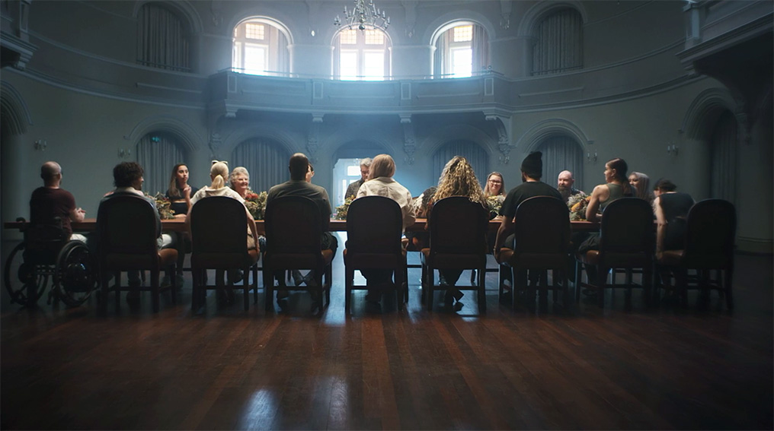

# Implementation Plan/ Moving Forward

## Outcome 1: People with disability have the same opportunities as other people to access the services of, and any events organised by, the Commission.

|  |  |
| --- | --- |
| **Strategy** | **Timeline** |
| Ensure that our employees, contractors and agents are aware of and comply with our DAIP. | Ongoing |
| Continue existing and explore new polling place accessibility options including wheelchair access, RAMP assist, provision of ACROD parking bays and drive in polling. | March 2024 |
| Ensure that events organised by the Commission continue to be accessible to people with disability. | Ongoing |
| Continue to ensure enrolment and early voting opportunities are promoted to electors with disability. | Ongoing |
| Review mobile polling at state elections that provides voting services to people in hospitals, institutions and aged care facilities and ensure they are well advertised. | March 2024 |
| Enable prospective casual employees to declare if they have a disability, which may affect their duties, so that suitable employment ca n be found. | March 2024 |
| Identify polling places close to public transport where possible. | March 2024 |

## Outcome 2: People with disability have the same opportunities as other people to access the buildings and other facilities of the Commission.

|  |  |
| --- | --- |
| **Strategy** | **Timeline** |
| Continue to include public access information, including location and accessible parking map, and public transport access links on the Commission’s website. | Ongoing |
| Ensure our offices meet legislative requirements for accessibility. | Ongoing |
| Ensure signage to our offices, facilities and polling places continues to be clear and easy to understand and increase signage during electoral events. | Ongoing |
| When training election staff, ensure that they are aware that as many as practicable polling places should cater for people with disability and polling places should be set up accordingly. | Ongoing |
| Advertise polling place lists in pre-election advertising and indicate those that are more accessible by using the wheelchair symbol. | March 2024 |

## Outcome 3: People with disability receive information from the Commission in a format that will enable them to access the information as readily as other people are able to access it.

| **Strategy** | **Timeline** |
| --- | --- |
| In consultation with people with disability and their representative organisations, review electronic/internet voting options. | March 2024 |
| Supply polling places with assistive tools including desktop voting compartments, magnifying sheets, Better Hearing counter cards, hearing loops, posters with infographs and other materials. | March 2024 |
| Review brochures designed for electors with disability, for appropriateness and distribution possibilities. | March 2024 |
| Ensure that upgrades to the Commission’s website are in a format suitable for people with disability and readable with screen-readers and other assistive technology. | Ongoing |
| Continue to explore the opportunities of new technologies to improve electoral services for electors with disability. | Ongoing |

## Outcome 4: People with disability receive the same level and quality of service from the staff of the Commission as other people receive from the staff of the Commission.

|  |  |
| --- | --- |
| **Strategy** | **Timeline** |
| The Commission to attend events relevant to people with disability and promotes its services. | Ongoing |
| Improve and maintain employee awareness about people with disability through promotion of events, materials and training. | Ongoing |
| Provide Disability Awareness training for Returning Officers prior to elections to ensure access and other needs of people with disability are understood. | March 2024 |
| Supply polling place staff with high vis vests so they are easily visible to electors who may need assistance. | March 2024 |
| Ensure Commission employees have ready access to the Commission’s Writing Accessible Documents guide. | Ongoing |
| Commit to ongoing reporting of our DAIP in the annual report and to the Disablity Services Commission. | Ongoing |

## Outcome 5: People with disability have the same opportunities as other people to make complaints to the Commission.

|  |  |
| --- | --- |
| **Strategy** | **Timeline** |
| Ensure the complaints system is accessible to people with disability. | Ongoing |
| Ensure that relevant Commission information channels refer to the complaints process. | Ongoing |
| Respond to complaints in a timely and respectful way. | Ongoing |

## Outcome 6: People with disability have the same opportunities as other people to participate in any public consultation by the Commission.

|  |  |
| --- | --- |
| **Strategy** | **Timeline** |
| Ensure when the Commission undertakes public consultation that people with disability and representative organisations are invited to attend. | Ongoing |
| Provide sufficient notice of meetings, suitable venues and an appropriate level of support to people with disability who are directly involved in consultation processes. | Ongoing |
| Assess the experiences of people with disability during elections. | Ongoing |

## Outcome 7: People with disability have the same opportunities as other people to obtain and maintain employment with the Commission.

|  |  |
| --- | --- |
| **Strategy** | **Timeline** |
| Review recruitment practices to ensure they are inclusive and accessible to people with disability. | Ongoing |
| Provide appropriate support for employees with disability. | Ongoing |

1. *WA Department of Communities,* [*A Western Australia for Everyone: State Disability Strategy 2020-2030*](https://www.wa.gov.au/government/document-collections/state-disability-strategy-2020-2030)*, (website), 2020,*

   <<https://www.wa.gov.au/government/document-collections/state-disability-strategy-2020-2030>>,

   (*accessed 20 December 2021)*